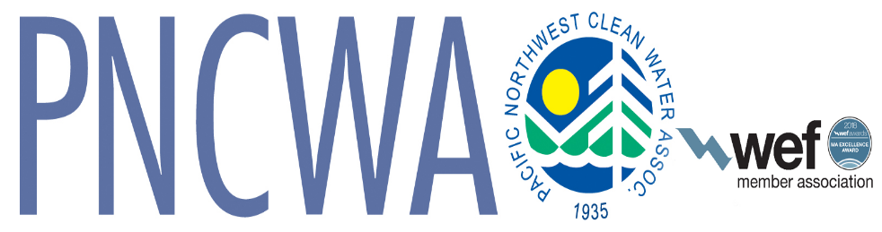

PNCWA Mission Statement:
Dedicated to protecting and enhancing water resources in the states of Idaho, Oregon and Washington. To achieve this, we promote the professional development of our members, the dissemination of information to the public and policy makers, and the advancement of science and technology needed to protect human health and the environment.
PNCWA Vision Statement:
The Pacific Northwest Clean Water Association is a vibrant community sustaining healthy watersheds for future generations.
PNCWA Guiding Principles:
Leadership
Stewardship
Collaboration
Integrity
Passion

