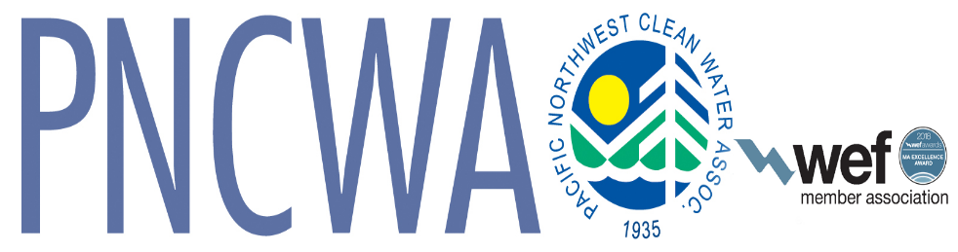

Pacific Northwest Clean Water Association Logo Use Policy
The PNCWA Logo represents the Association’s identity and integrity. The PNCWA logo is to be used only as described below.
PNCWA’s logo is generally used in conjunction with the WEF logo according to the specifications of the licensing agreement with the Water Environment Federation. The current licensing agreement is on file in the Association offices. An important element of that agreement states, “WEF hereby grants PNCWA a non-exclusive, royalty-free, worldwide, revocable license to use the following trademarks and service marks which are the sole property of WEF: Wave symbol, WEF Logo and ® symbol.”
PNCWA Logo:
The name, symbol, and foundation date are the three elements that make up the logo and shall always be used together as one element.
Use of PNCWA Logo
The logo shall be included on all printed materials used in communicating PNCWA messages and for PNCWA and PNCWA Committee events or business.
PNCWA Regions and Sections may use the logo on all materials related to official Region and Section business with the following limitations:
- Regions will use the “PNCWA Region” logo for all Regional events or business.
- Sections may use the “PNCWA” along with their own section logo in which case the Section logo will appear dominant and the PNCWA logo will appear in a supportive role. Sections may not use the PNCWA Logo by itself, it must always be in conjunction with some identifying feature or type that indicates the Section.
- If the Section does not have their own logo the Section name shall appear dominant and the PNCWA logo shall be used in a supportive role.
- PNCWA members may use the logo with the word “Member” under the logo in a typeface and point size similar to the PNCWA text.
Size: As required to fit application.
Colors: As a package: Green: Pantone 356, Blue: Pantone Reflex Blue, Yellow: Pantone Yellow or Process Yellow. Other package: Black
For questions about usage contact PNCWA Staff Michael Rainey, mikerainey@pncwa.org

1/2019

